A picture containing clipart

Description generated with very high confidence

Hands-on

Creating a Elastic Network Interface

AWS Solutions Architect

[**support@intellipaat.com**](mailto:support@intellipaat.com)

**+91-7022374614**

**US: 1-800-216-8930(Toll Free)**

**Creating a Elastic Network Interface**

**Step 1:** Go to Network Interfaces under the EC2 dashboard and select Create Network Interface.

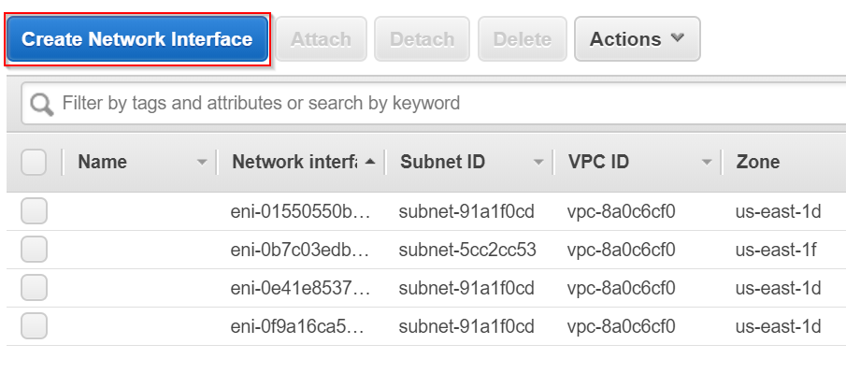

**Step 2:** Then provide an apt description (optional) and then choose the Subnet under which your instance is available or under which you will create the instance. Also, choose the security group for the Network Interface.

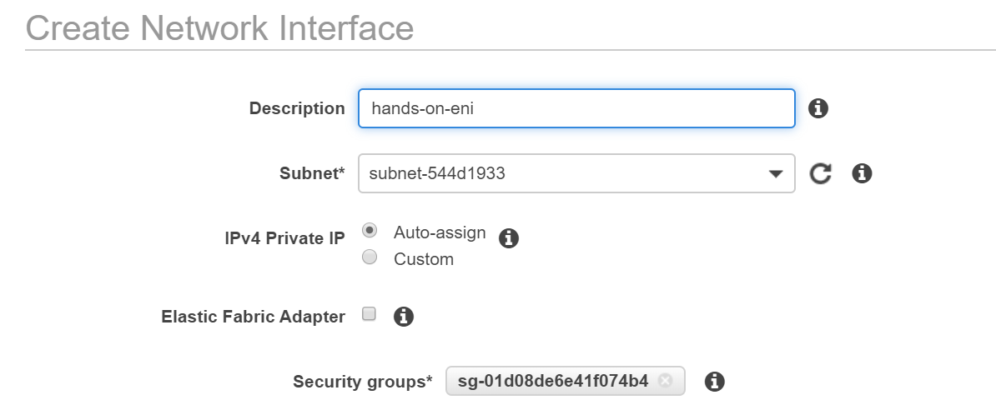

**Step 3:** The Network Interface has been successfully created.

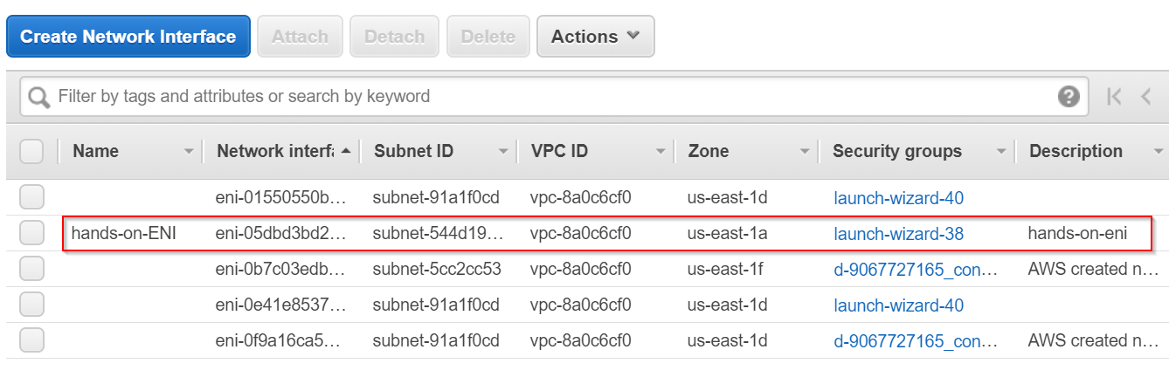

**Step 4:** Now, while creating your EC2 instance, under Configure Instance, go to Network Interfaces and choose the Network interface which you just created.

**Note:** The Network Interface will be only visible if you entered the right subnet

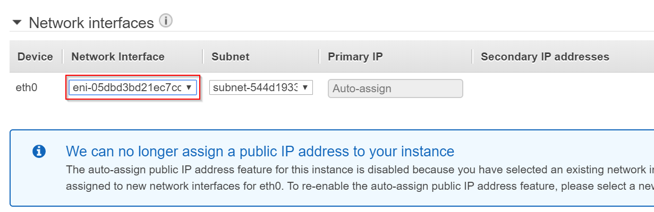

**Step 6:** Here, the Interface ID of the network interface is visible under the instance details.

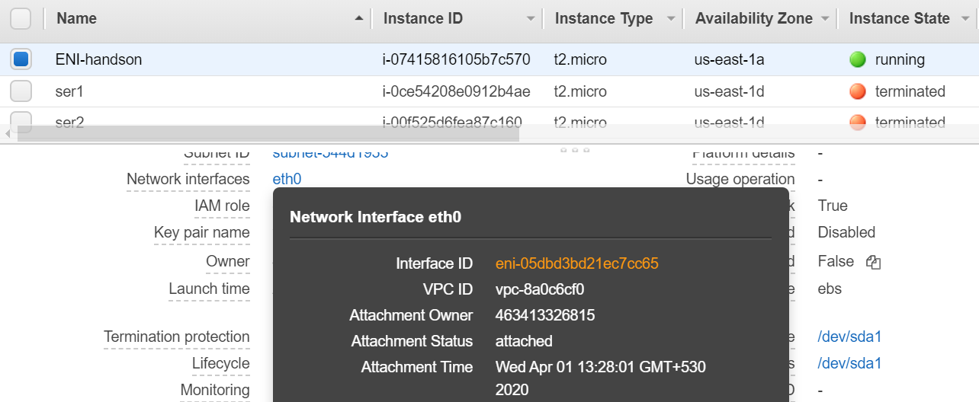

**Step 7:** Now let us Allocate an Elastic IP address to attach to the Network Interface

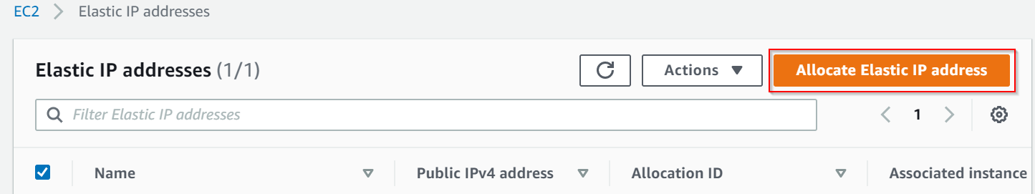

**Step 8:** Now, click Allocate to create an Elastic IP address

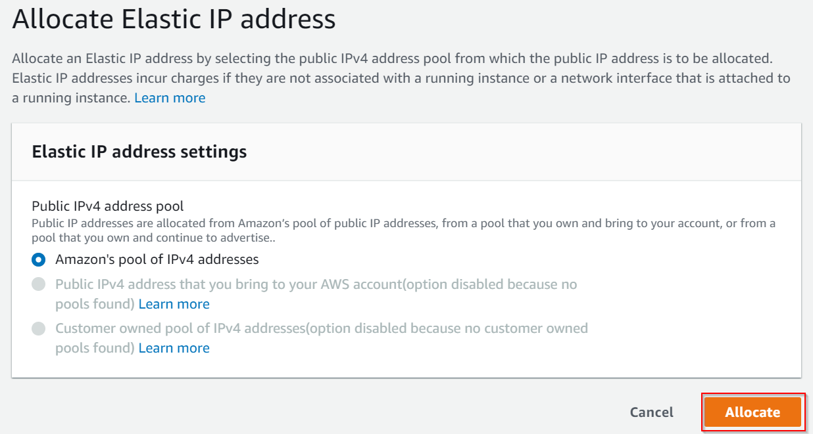

**Step 9:** Elastic IP address is successfully created.

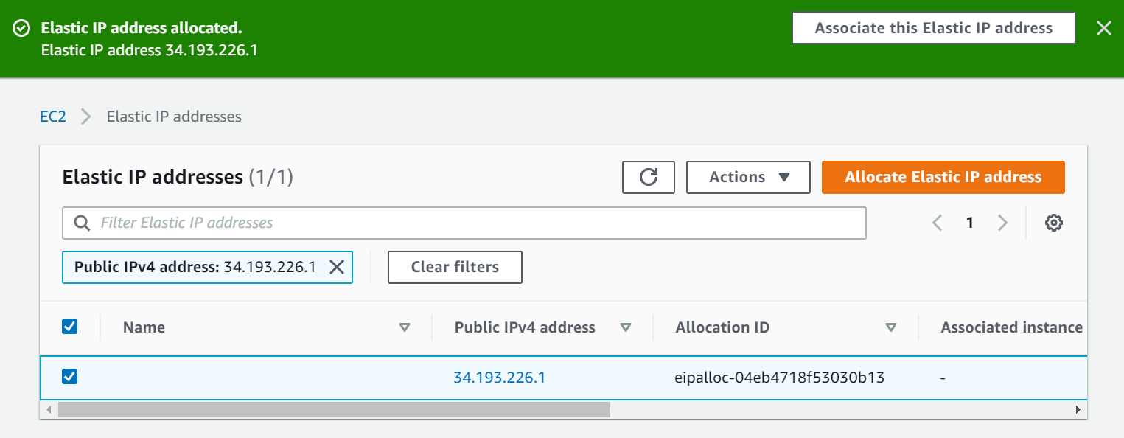

**Step 10:** Now, select the Network Interface you want to attach the IP to. Actions 🡪 Associate Address.

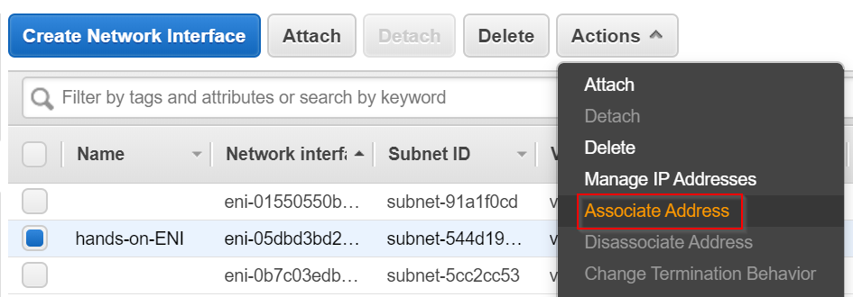

**Step 11:** As shown below, attach the IP and click on Associate Address

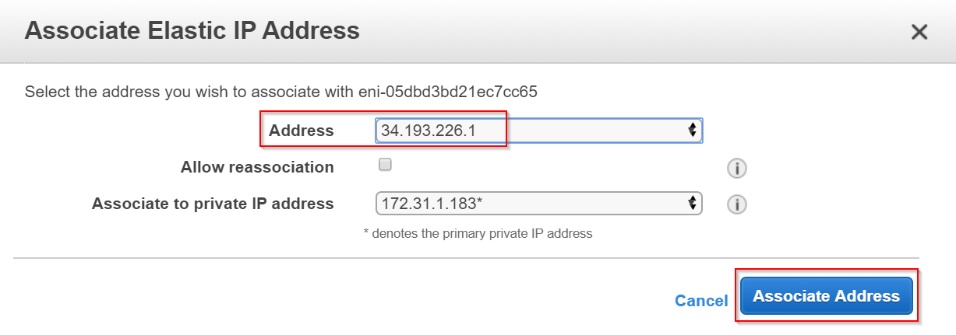

**Step 12:** Now, let us check whether the instance opens with associated IP address

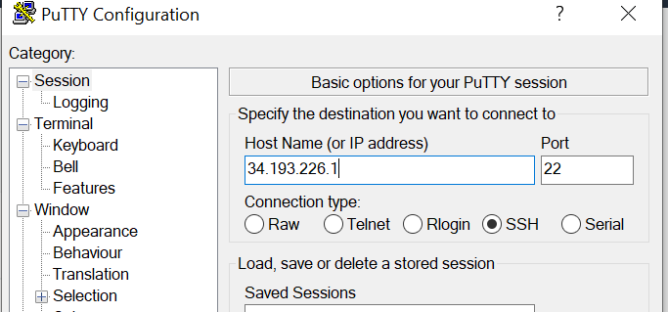

**Step 13:** The session started successfully! We have created an ENI and attached it to an EIP.

